**MOBILE PROGRAMMING PROJECT PLANNING**

**Yağmur Sude YOLCU**

**20200305036**

**Topic:** Electronic menu and order applications for restaurants.

My Project name is Yummy In The Tummy. My Project purpose is developing an electronic menu application for tablets in a restaurant to enhance the overall dining experience. By providing customers with a convenient and visually appealing platform, they can browse, customize, and place orders at their own pace. This system promotes efficiency by streamlining the ordering process, enabling faster service and freeing up staff to focus on customer satisfaction.

These are the steps that I am planning to implement:

1)First Screen (Welcome to Yummy In The Tummy)

2)Choosing table in tablet

3)Categorized food like dessert, beverage, salad ,meals etc.(The customer can increase quantity of the product and see the prices.I will add foods’ detail information . For example when customers wants to order, they can see all the information. For instance, they want classic pizza.They can see all the ingredients in pizza, they can remove any ingredients that they don't want.

4) The customer may have added the wrong product or may have given up so I will add delete button.

5)I am going to add an area where customers can leave any notes regarding the order.

6)I am going to implement some features for handling customer feedback, promotions

7)Lastly,I am going to make “My Order”page. Before they give an order this screen will display. After customer decided their order , they can click to confirm order button.

8)Of course all of this information will be connected to the database. Thanks to this, orders will be placed on the preparation screen and prepared, customers' feedback will be seen, and a path will be followed accordingly.

*Topluluk Tarafından Doğrulandı simgesi*

**Here is my flowchart.**

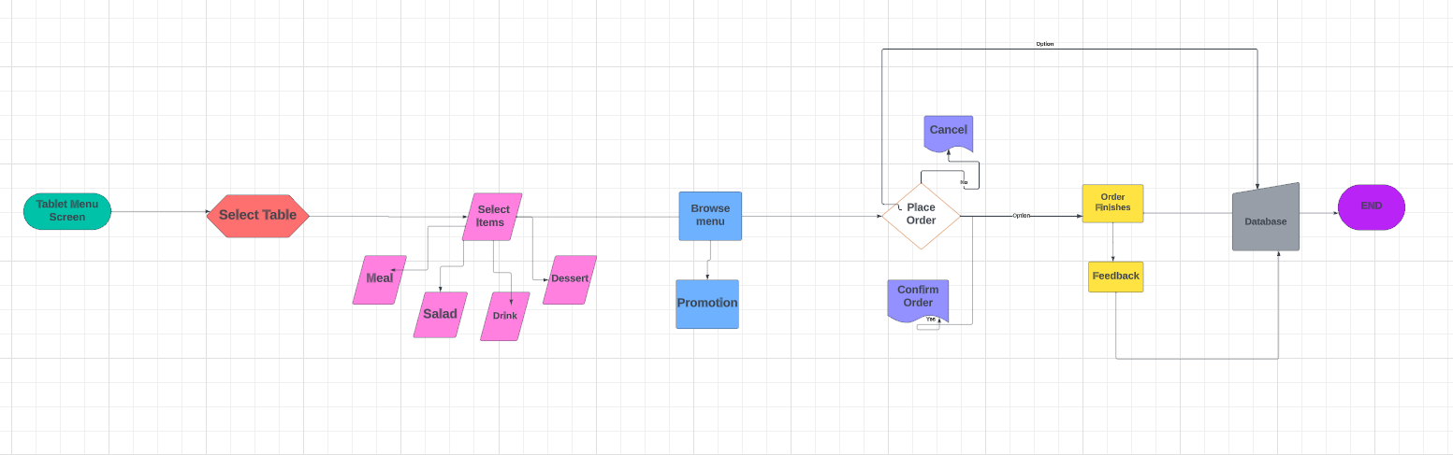

I want to show that first page that ı am planning to make.

In order to appeal to the eye for customers and to understand the content of the menu , I will add images of plenty of dishes, desserts, salads and drinks.I am going to save these pictures in res----🡪 drawable page.

My project consist of design for each screen ,including the main menu, category pages (desserts, beverages, salads, meals), selecting table,detailed product pages(product ingredientd,adding-canceling product), promotion,order summary,feedback part and confirmation screen.As ı mentioned above,these information will be connected to database. Project appereances will be attractive, elegant and will not tire the eyes.

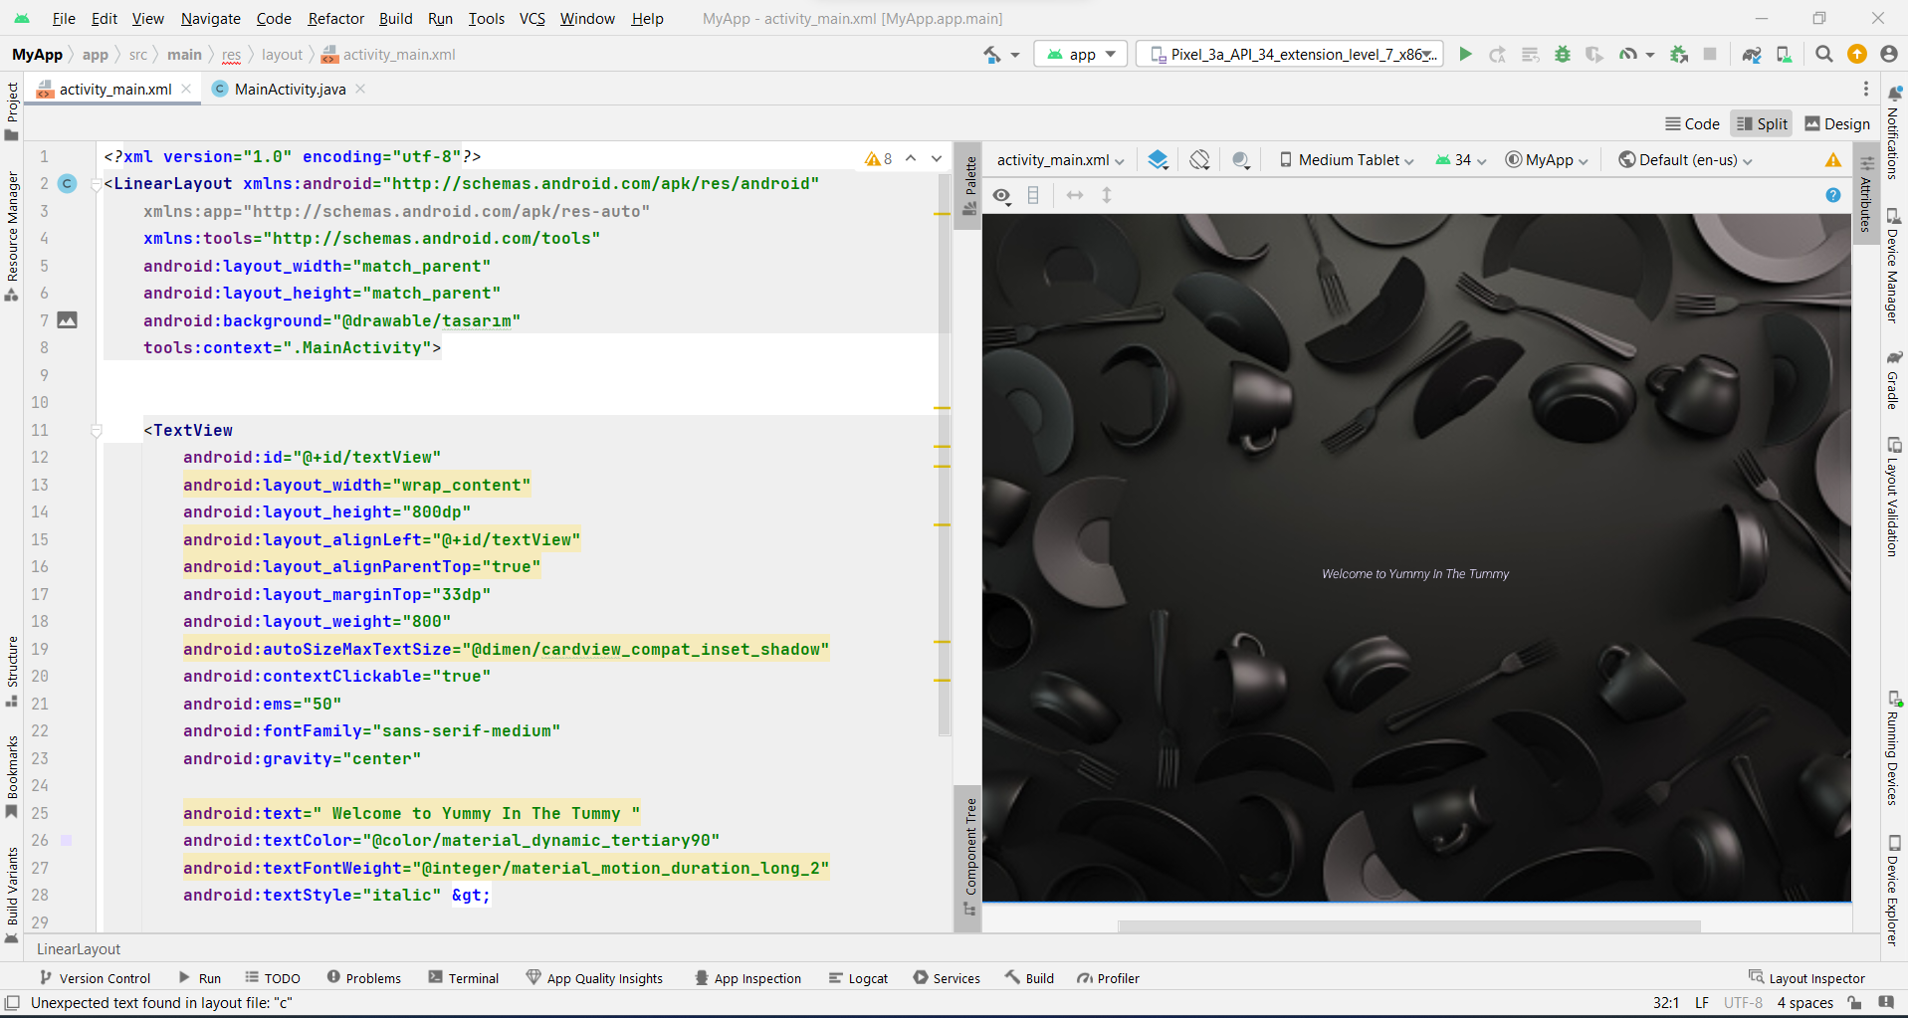

While doing first screen in my Project, I have watched this video: <https://www.youtube.com/watch?v=BvfihLKuV0>

<https://www.youtube.com/watch?v=zSqibjyZeMs&list=PLLTtZhOwITShnOaSJ6TvzfIeuZd7>